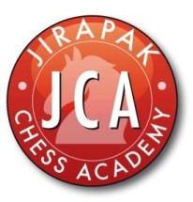

HARROW INTER-SCHOOL CHESS TOURNAMENT 2013

Schedule of event U14/16/19

Time control 30/0

07.30-08.30 Registration
08.30-09.00 Opening ceremony
09.00-10.00 Round 1
10.30-11.30 Round 2
12.00-13.00 Lunch break

13.00-14.00 Round 3
14.20-15.20 Round 4
15.40-16.40 Round 5
17.00-18.00 Prize giving and closing ceremony

