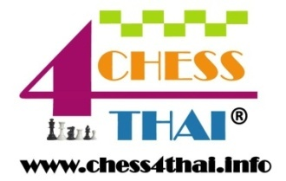
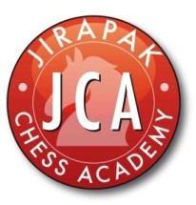

HARROW INTER-SCHOOL CHESS TOURNAMENT 2013

Schedule of event U8/10/12

Time control 20/0

07.30-08.30 Registration
08.30-09.00 Opening ceremony
09.00-09.40 Round 1
10.00-10.40 Round 2
11.00-11.40 Round 3
12.00-13.00 Lunch break

13.00-13.40 Round 4
14.00-14.40 Round 5
15.00-15.40 Round 6
16.00-16.40 Round 7
17.00-18.00 Prize giving and closing ceremony

