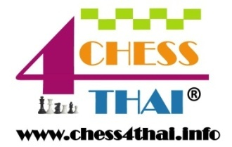
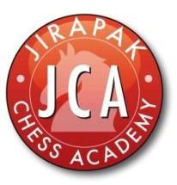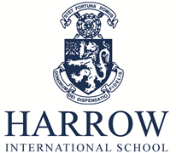

HARROW INTER-SCHOOL CHESS TOURNAMENT 2013

Venue: Harrow International School Assembly Hall

Date & Time: 16th November, 2013: 07.30 - 18.00

System: Swiss system / 7 rounds for U8/10/12
Swiss system / 5 rounds for U14/16/19

Official arbiters: IO Kai Tuorila (International Organiser)
FM Jirapak Pitirotjirathon (Fide Master)
Time control: 20 minutes for U8/10/12
30 minutes for U14/16/19

Categories: U8/10/12/14/16/19 (age as of 16.11.13)

Entry fees: THB 600 including lunch (register & pay before 01.11.13)
THB 800 including lunch (register & pay before 11.11.13)
THB 1000 without lunch and play in Round 2 (walk-in)

Payment details: Account number: 105-2-34588-4

Account Name: Harrow Asia Limited

Bank: Siam Commercial Bank
Cherdwutthakat Branch
199/278 Moo 11 Cherdwutthakat Road
Don Muang,
Bangkok 10210

Swift Code: SICOTHBK

Registration: http://hisvle.harrowschool.ac.th/index.phtml?d=629815

Prizes: 1st, 2nd and 3rd in each boys’ category (trophies)

1st and 2nd in each girls’ category (trophies)

1st, 2nd and 3rd – international school teams (trophies)

Medals & certificates for the first 200 players who register online and pay before 01.11.13

Lunch: Buffet lunch (normal/vegetarian)

Proof of Age: Copy of an official document showing the date of birth, i.e. student’s report book, passport, or student ID card

Contact (English)

Mobile: Mrs. Jess Grimshaw (087-981-0879, 080-218-6668)

E-mail: jess_g@harrowschool.ac.th

Contact (Thai)

Mobile: Mr. Jirapak Pitirotjirathon (085-252-4800)

E-mail: jirapakchess@gmail.com

Mobile: Mr. Worawong Pattanawong (086-566-3144)

E-mail: ying4u@facebook.com

